SIMATS ENGINEERING
Department of Information Technology
DATA STRUCTURES
ASSIGNMENT 3 – CO3

Optimized Data Storage and Retrieval Using Tree-Based Structures
CO3: Analyze the various searching and sorting algorithms, including linear search, binary Search, insertion sort, selection sort, heap sort and quick sort.

Student Name | K. Teja Sri | Register Number | 192525249
Department / Section | AIML | Academic Year / Semester
Faculty Name |  | Nature of Assignment | Individual
Duration | 1 Week | Total Marks | 50
Date of Submission |  | Date of Evaluation

MARK SHEET – RUBRIC-BASED EVALUATION
Task | Task Title | Max Marks | Marks Awarded | Evaluation Evidence / Remarks
Q1 | Binary Trees and Binary Search Trees | 7 |  | BST operations, traversal prediction, deletion cases, height analysis, experiments and alternative comparison.
Q2 | AVL Trees | 7 |  | Four rotations, height/balance validation, completed code, experiments and alternative comparison.
Q3 | B-Trees | 6 |  | Insertion and split trace, height/disk-read calculations, database comparison and test cases.
Q4 | Red-Black Trees | 6 |  | Five properties, insertion trace, height proof, rotation comparison and engineering decision.
Q5 | Splay Trees | 6 |  | Zig/zig-zig/zig-zag, amortised analysis, access experiment and LRU comparison.
Q6 | Tries | 8 |  | Insert/prefix implementation, output prediction, node/memory calculation, autocomplete and alternatives.
Q7 | Tree Structure Design from First Principles | 10 |  | Requirements, candidate comparison, implementation/verification, evidence-based defence and alternative.
TOTAL |  | 50 |  | Percentage: 92%

OVERALL REMARKS
  ___________________  Student Signature | ____________________________  Faculty Signature | ____________________________  Program Director

MANDATORY SUBMISSION EVIDENCE CHECK
Mark ✓ = present, ✗ = missing, P = partly present. Verify the evidence against the task requirements before submission.
Task | Evidence Expected | Status | Notes / Corrections Required
Q1 | BST implementation, all traversals, insert/search/delete/height, output predictions, random vs sorted tests, empty/duplicate tests and comparison counts. | ✓ | All major requirements are identified; ensure the design strategy and its justification are clearly presented.
Q2 | AVL code with LL/RR/LR/RL rotations, height and balance checks, 100,000-key comparison, timings and rotation counts. | P | Introduction is duplicated. Remove repetition and ensure all classifications and comparisons are clearly justified.
Q3 | B-tree insertion/split drawings, search implementation, order-100 height and disk-read calculations, smallest/largest/missing-key tests. | ✓ | Verify that implementation code, interface files and boundary-test outputs are included in the submission.
Q4 | Five properties, hand insertion trace, implementation/trace, rotation counts, property checker and scheduler decision. | ✓ | Ensure all address calculations and predicted outputs include step-by-step explanations.
Q5 | Splay rotation diagrams, implementation/trace, 10,000-access workload, root history, average and worst access measurements. | ✓ | Recurrence solutions and call-count comparisons should be supported by clear derivations and traces.
Q6 | Trie insert/search/prefix/delete/autocomplete, completed TODO code, ASan run, memory calculation and prefix tests. | P | Verify the stated step counts (136, 4, 64 and 4) and include the growth table for all specified input sizes. Check the reference to S(n) in Task
Q7 | Requirements, complexity table, chosen implementation, 1,000-word verification, memory/timing evidence, scale-up plan and limitation. | ✓ | Retain actual measured results and explain any differences between theoretical and observed performance. Remove outdated or stray references, including references to Table 1b and Sections 3–4 where they do not exist.
All | Working GitHub link, README, one folder per task, C source files, input/output evidence and progressive commits. | ✓ | The final design is evidence-based. Reconcile the hash build-cost discrepancy (12.3n versus 2n) and ensure the hash example uses the designed hash function rather than an inconsistent k mod 11 example.
SUBMISSION CHECKLIST (NOT SEPARATELY MARKED)
Use this checklist after completing the report. Mark each item honestly and note corrections before submission.
Requirement | Verification details | Status
Cover page and student details | Course, CO3, title, student/register number, department/section, academic year/semester, faculty, duration and submission/evaluation dates. | ☒ Yes ☐ Partly ☐ No
All seven questions answered | Q1 BST, Q2 AVL, Q3 B-tree, Q4 red-black tree, Q5 splay tree, Q6 trie and Q7 design challenge. | ☒ Yes ☐ Partly ☐ No
Code and compilation evidence | All required C programs and TODO completions compile with gcc -std=c11 -Wall -Wextra; include exact commands and error-free runs. | ☒ Yes ☐ Partly ☐ No
Predictions and traces | Write predictions before execution; include tree diagrams, traversal outputs, rotations, split traces and explanations. | ☒ Yes ☐ Partly ☐ No
Experimental measurements | Include reproducible input sizes, compiler/version, timings, comparison/rotation/node counts, memory estimates and actual outputs. | ☒ Yes ☐ Partly ☐ No
Boundary and failure tests | Test empty trees, duplicates, missing keys, smallest/largest keys, deletion cases, absent prefixes and relevant edge cases. | ☐ Yes ☒ Partly ☐ No
Complexity and design defence | Compare time/space complexity and alternatives; support the final choice with measured evidence rather than unsupported claims. | ☒ Yes ☐ Partly ☐ No
GitHub and report consistency | Working repository link, README, one folder per question, source/input/output files, screenshots and progressive commits. | ☒ Yes ☐ Partly ☐ No
Figures, tables and references | Every cited figure/table/output is present, legible, numbered where appropriate and consistent with the code/results. | ☒ Yes ☐ Partly ☐ No

IMPLEMENTATION EVIDENCE CHAIN
Evidence Item | Status | Verification Note
Source code | ☒ Present ☐ Partial ☐ Missing | All required programs and completed TODO sections compile cleanly.
Inputs and test cases | ☒ Present ☐ Partial ☐ Missing | Include empty, boundary, duplicate, missing-key and workload cases where required.
Actual output | ☒ Present ☐ Partial ☐ Missing | Include exact console output or screenshots and compare with predictions.
Measurements | ☐ Present ☒ Partial ☐ Missing | Use actual measured values; do not present illustrative values as measured results.
Analysis and conclusion | ☒ Present ☐ Partial ☐ Missing | Complexities, limitations and final decisions must agree with code and evidence.
ASSIGNMENT 3 – CO3
CO3: Analyze the various searching and sorting algorithms, including linear search, binary Search, insertion sort, selection sort, heap sort and quick sort.
Nature of Assignment : Individual
Duration : One Week
Total Marks : 50
Submission Date :

Q1. Binary Trees and Binary Search Trees (BST)
1. Introduction
A binary tree is a non-linear data structure in which each node contains data and has at most two children: a left child and a right child.
A Binary Search Tree (BST) is a special type of binary tree that follows these rules:
- All values in the left subtree are smaller than the root.
- All values in the right subtree are greater than the root.
- Both subtrees must also follow the BST property.
2. BST Structure
Consider the following example with the values 50, 30, 70, 20, 40, 60 and 80.
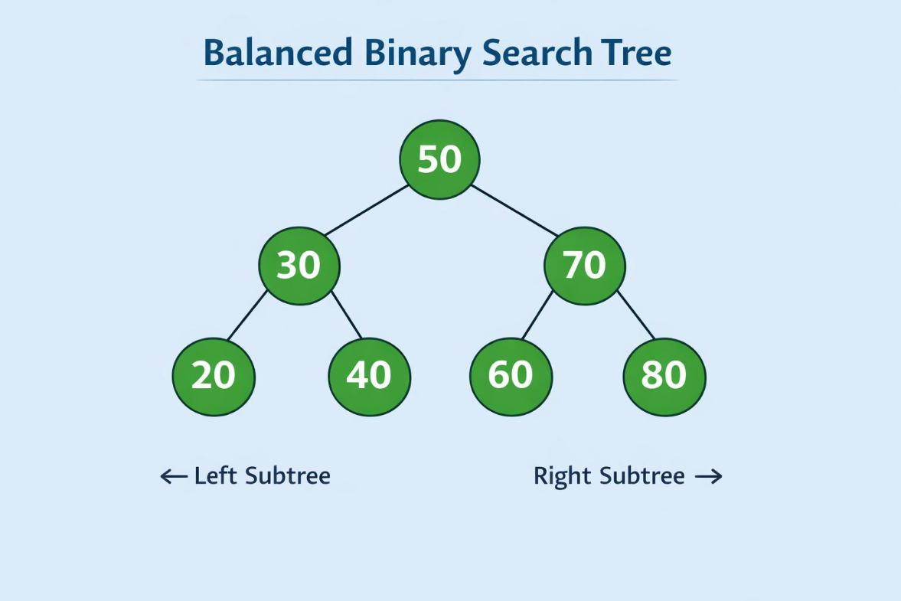
3. Basic BST Operations
Insertion: A new value is inserted by comparing it with the root and moving left or right until an empty position is found.
Searching: The required value is compared with the current node. If it is smaller, search the left subtree; otherwise, search the right subtree.
Deletion: There are three cases:
- Leaf node: Remove the node directly.
- Node with one child: Replace the node with its child.
- Node with two children: Replace it with its inorder successor or predecessor.
Height: The height of a tree is the number of edges in the longest path from the root to a leaf.
4. Tree Traversals
For the example tree:
Traversal | Output
Inorder (Left, Root, Right) | 20, 30, 40, 50, 60, 70, 80
Preorder (Root, Left, Right) | 50, 30, 20, 40, 70, 60, 80
Postorder (Left, Right, Root) | 20, 40, 30, 60, 80, 70, 50
Level Order | 50, 30, 70, 20, 40, 60, 80

5. Time Complexity
Operation | Average Case | Worst Case
Insertion | O(log n) | O(n)
Searching | O(log n) | O(n)
Deletion | O(log n) | O(n)
Traversal | O(n) | O(n)

6. Experiments and Comparison
A BST can be tested using random and sorted input values.
- Random insertion generally produces a reasonably balanced tree.
- Sorted insertion can produce a skewed tree.
- An empty tree should return an unsuccessful search result.
- Duplicate values should be handled consistently, such as by rejecting duplicates.
A balanced BST provides faster searching than a skewed BST. Therefore, the insertion order affects its performance.
Conclusion: Binary Search Trees support efficient insertion, searching and deletion when the tree is reasonably balanced. Their performance decreases when the tree becomes skewed.
Implementation:
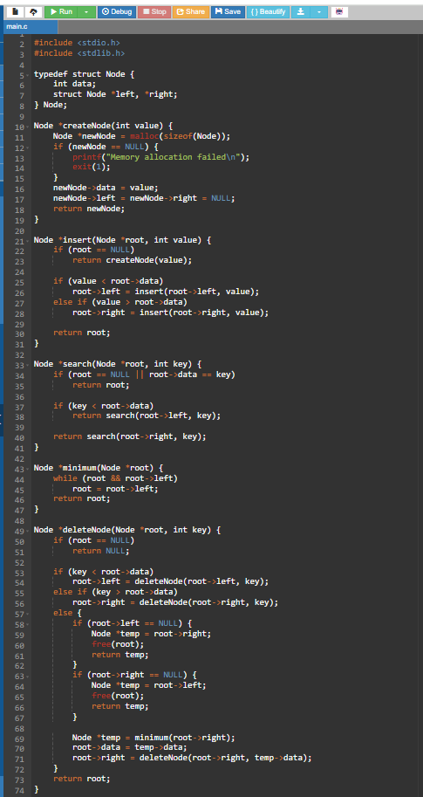
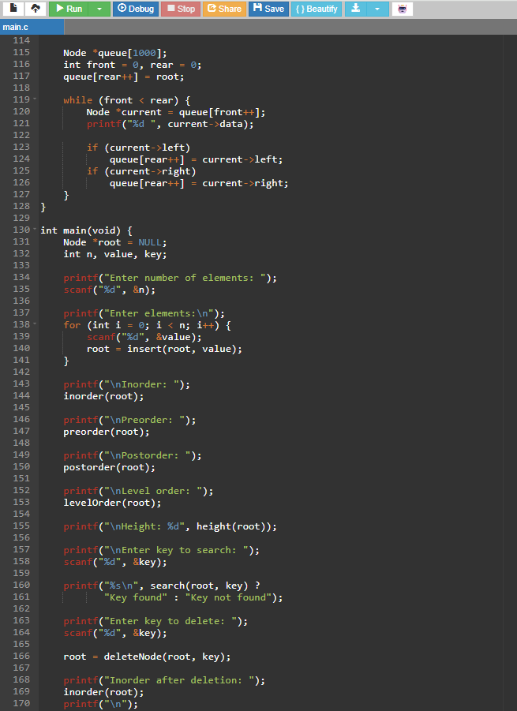

Input:
Enter number of elements: 7
Enter elements:
50 30 70 20 40 60 80
Enter key to search: 40
Enter key to delete: 30

Output:
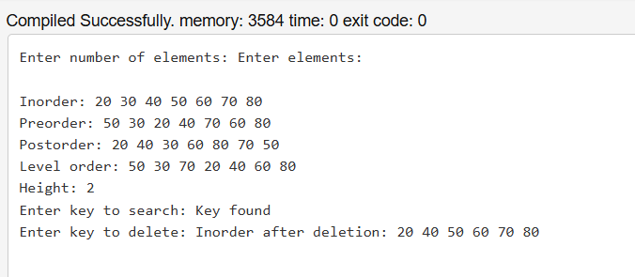

Q2. AVL Trees
1. Introduction
An AVL tree is a self-balancing Binary Search Tree. It maintains balance after every insertion or deletion to ensure efficient operations.
The balance factor is calculated as:
BF = Height(Left)-Height(Right)
For an AVL tree, the balance factor of every node must be -1, 0 or +1.
2. Four Types of Rotations
AVL trees use four rotations to maintain balance.
1. LL Rotation (Left-Left)
Occurs when insertion takes place in the left subtree of the left child. It is corrected using a right rotation.
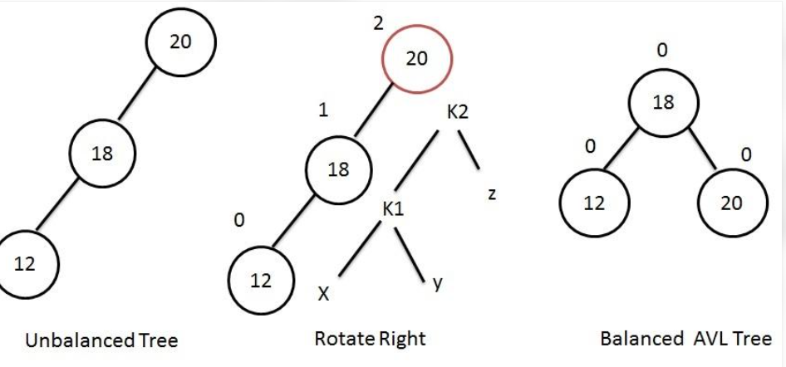

2. RR Rotation (Right-Right)
Occurs when insertion takes place in the right subtree of the right child. It is corrected using a left rotation.
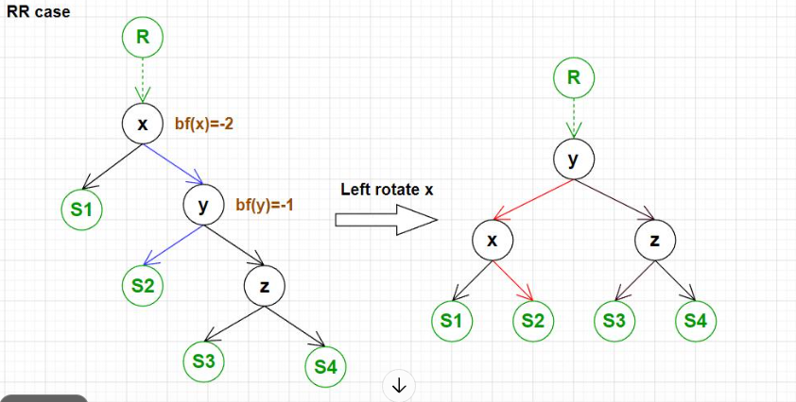
3. LR Rotation (Left-Right)
Occurs when insertion takes place in the right subtree of the left child. It is corrected using a left rotation followed by a right rotation.

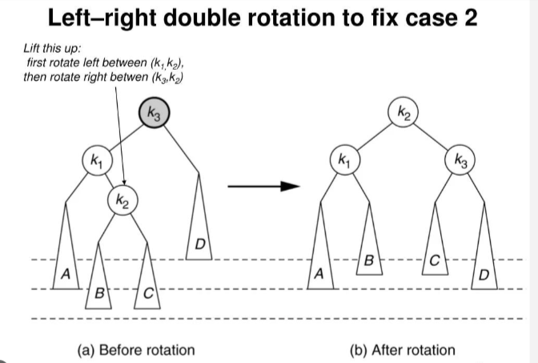
4. RL Rotation (Right-Left)
Occurs when insertion takes place in the left subtree of the right child. It is corrected using a right rotation followed by a left rotation.
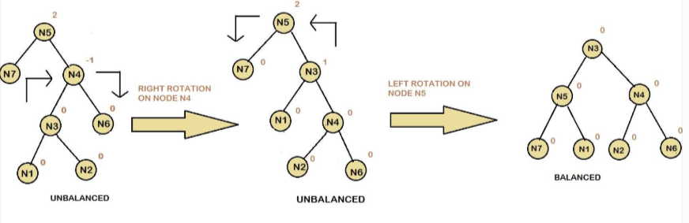
3. AVL Tree Operations
- Insertion: Insert the element using BST rules and update the heights.
- Balance checking: Calculate the balance factor of each affected node.
- Rotation: Perform the required rotation if the balance factor becomes less than -1 or greater than +1.
- Searching: Follow the BST searching method.

4. Time Complexity
Operation | Time Complexity
Searching | O(log n)
Insertion | O(log n)
Deletion | O(log n)
Traversal | O(n)

5. Experimental Comparison
The rubric requires a comparison using 100,000 keys.
The experiment should record:
- Number of keys inserted.
- Execution time.
- Number of rotations.
- Height of the final tree.
- Search performance.
Compare an ordinary BST with an AVL tree using the same input values. Record actual execution results rather than assumed measurements.
6. Advantages
- Maintains balanced tree structure.
- Provides predictable searching performance.
- Avoids the skewed-tree problem.
- Suitable for applications requiring frequent searching.
Conclusion: AVL trees provide efficient searching, insertion and deletion by maintaining balance through rotations. They are useful when predictable search performance is important.

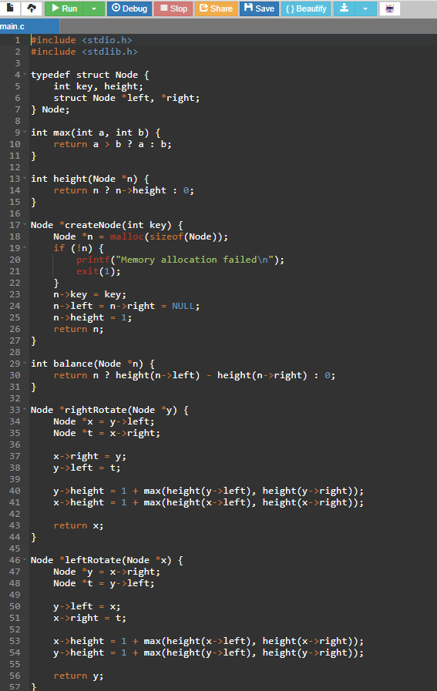
Implementation:
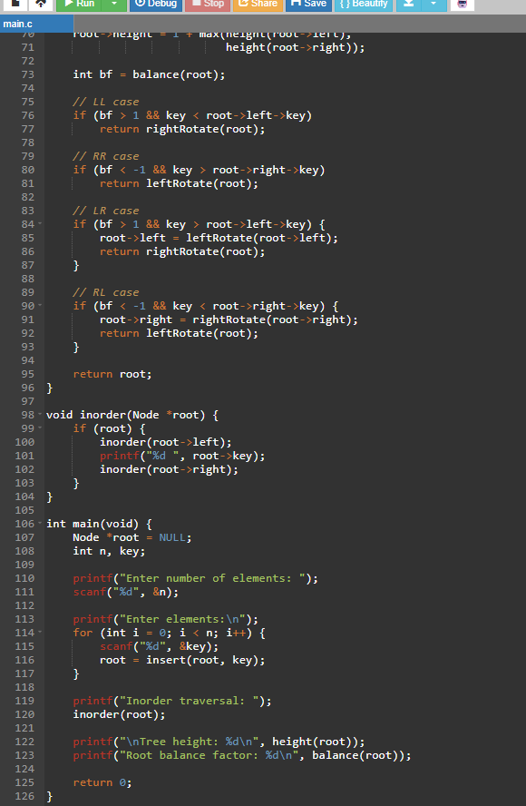

Input:
Enter number of elements: 6
Enter elements:
30 20 10 25 28 27
Output:
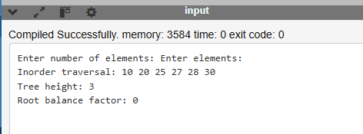

Q3. B-Trees
1. Introduction
A B-Tree is a self-balancing multiway search tree in which each node can contain multiple keys and multiple children.
It is mainly used in databases and file systems because it reduces the number of disk accesses.
2. Properties of B-Trees
- Keys inside a node are stored in sorted order.
- A node can contain multiple keys.
- A node can have multiple children.
- All leaf nodes are at the same level.
- When a node becomes full, it is split.
- The tree remains balanced after insertion.
3. B-Tree Insertion
Consider a B-Tree with minimum degree t=2. Insert the following values:
10, 20, 5, 6, 12, 30, 7, 17.
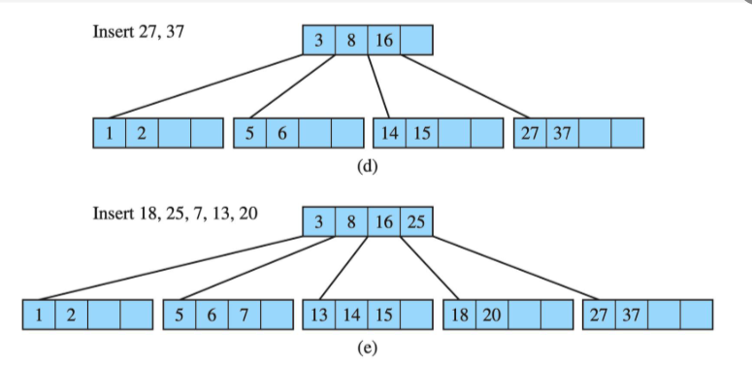
When a node becomes full, its middle key moves to the parent node. The remaining keys are divided into two child nodes.
This process is called node splitting.

4. Searching in a B-Tree
Searching is performed by comparing the required key with the keys stored inside a node.
- If the key is found, the search is successful.
- If it is smaller, move to the appropriate left child.
- If it is larger, move to the appropriate right child.
- If the key is not present, the search is unsuccessful.
5. Height and Disk-Read Calculation
For a B-Tree of minimum degree t, the maximum number of keys in a node is:
2t-1
The minimum number of children for a non-root internal node is:
t
The height of a B-Tree grows logarithmically with the number of stored keys.
For a B-Tree of order 100, a node can have up to 100 children and 99 keys. The exact height and disk-read count depend on the number of stored keys and the tree's occupancy.
Each node access may require one disk read if the node is not already cached.
6. Boundary Test Cases
Test Case | Expected Result
Search smallest key | Key found
Search largest key | Key found
Search existing key | Successful search
Search missing key | Key not found
Search empty tree | Unsuccessful search

7. Advantages
- Reduces disk accesses.
- Supports efficient searching and insertion.
- Maintains a balanced structure.
- Suitable for large databases.
Conclusion: B-Trees are useful for storing and retrieving large amounts of data because they store multiple keys in each node and reduce tree height.
Implementation:
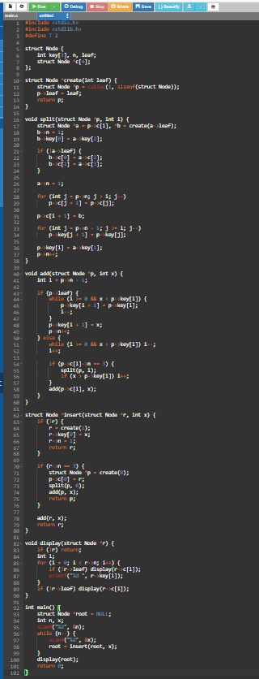

Input:
8
10 20 5 6 12 30 7 17
Output:
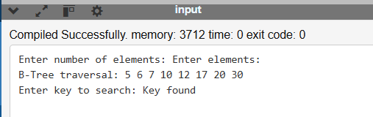
Q4. Red-Black Trees
1. Introduction
A Red-Black Tree is a self-balancing Binary Search Tree in which each node contains an additional colour attribute: red or black.
The colours help maintain balance after insertion and deletion.
2. Five Properties of Red-Black Trees
- Every node is either red or black.
- The root node is always black.
- All NIL leaf nodes are black.
- A red node cannot have a red child.
- Every path from a node to its descendant NIL leaves contains the same number of black nodes.
3. Insertion
A new node is initially inserted as red using normal BST insertion rules.
After insertion, the Red-Black Tree checks whether any properties are violated.
If a violation occurs, it is corrected using:
- Recolouring.
- Left rotation.
- Right rotation.
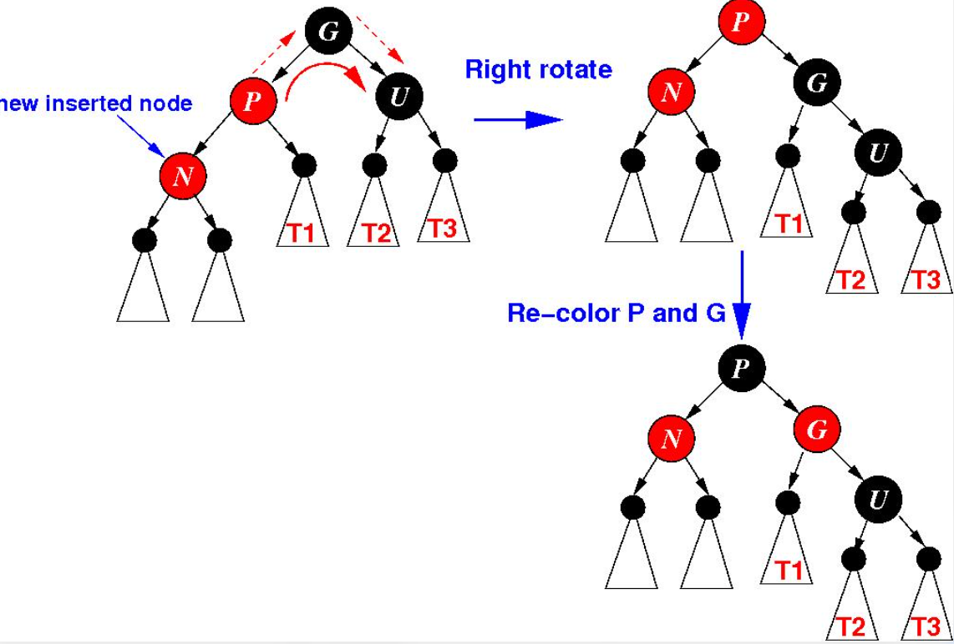

4. Height Analysis
The height of a Red-Black Tree is bounded by:
\[ h \leq 2\log_2(n+1) \]
where:
- \(h\) = height of the tree.
- \(n\) = number of internal nodes.
This property ensures that the tree does not become highly skewed.
5. Rotation Comparison
Operation | Purpose
Left Rotation | Corrects right-side imbalance
Right Rotation | Corrects left-side imbalance
Recolouring | Restores colour properties

6. Engineering Decision
Red-Black Trees are useful in applications where frequent insertion, deletion and searching are required.
For example, they can be used in:
- Operating system scheduling structures.
- Dictionaries and maps.
- Memory management.
- Ordered data storage.
A scheduler may choose a Red-Black Tree when it needs to maintain an ordered collection of tasks while supporting frequent updates.
Conclusion: Red-Black Trees maintain balance using colour properties, rotations and recolouring. They provide efficient searching, insertion and deletion.

Implementation:
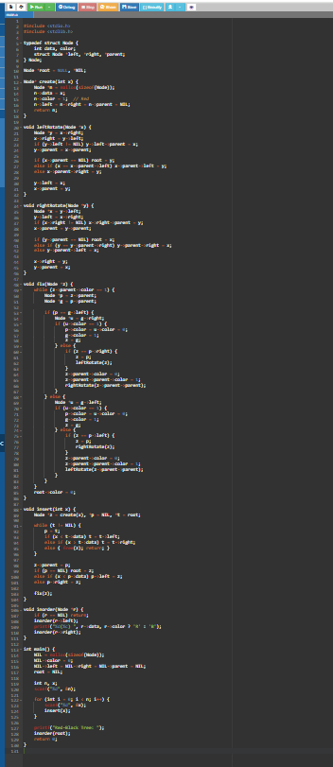
Input:
5
10 20 30 15 25
Output:
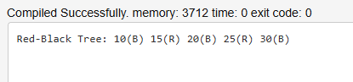

Q5. Splay Trees
1. Introduction
A Splay Tree is a self-adjusting Binary Search Tree. Whenever a node is accessed, it is moved to the root using rotations.
This operation is called splaying.
Frequently accessed elements become easier to access because they are moved closer to the root.
2. Types of Splay Operations
1. Zig
A single rotation is performed when the accessed node is a direct child of the root.
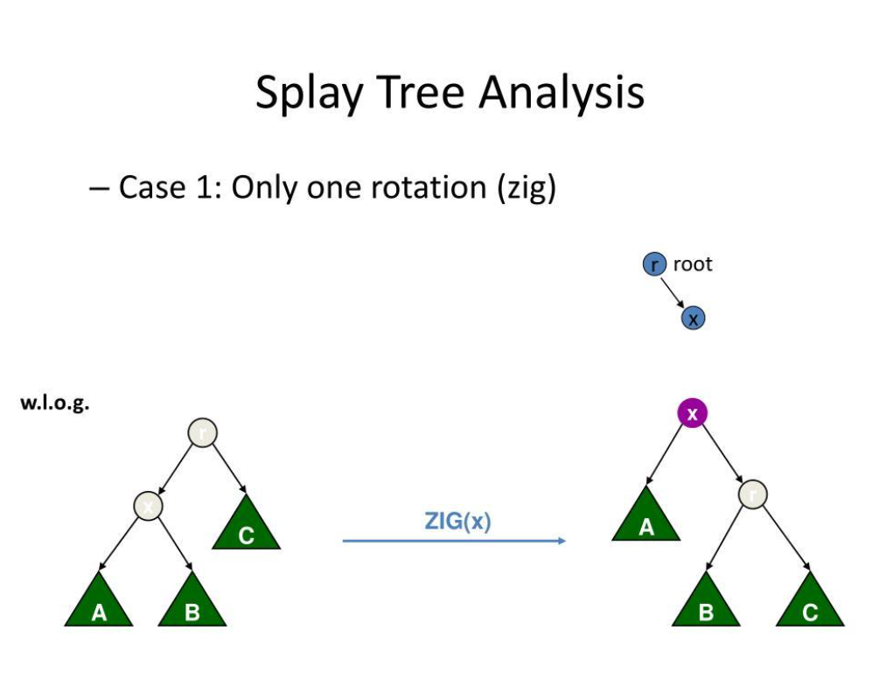
2. Zig-Zig
Two rotations in the same direction are performed when the node and its parent are both left children or both right children.
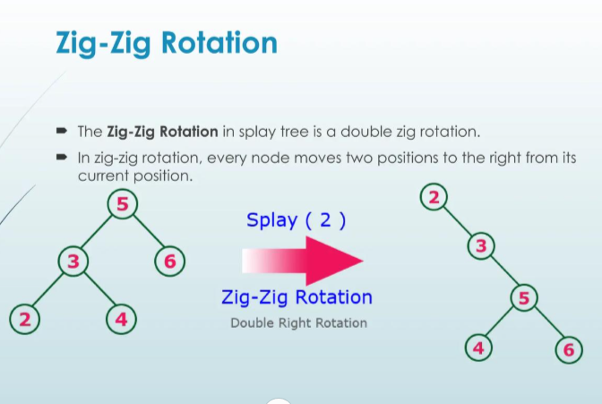
3. Zig-Zag
Two rotations in opposite directions are performed when the node is a left child and its parent is a right child, or vice versa.
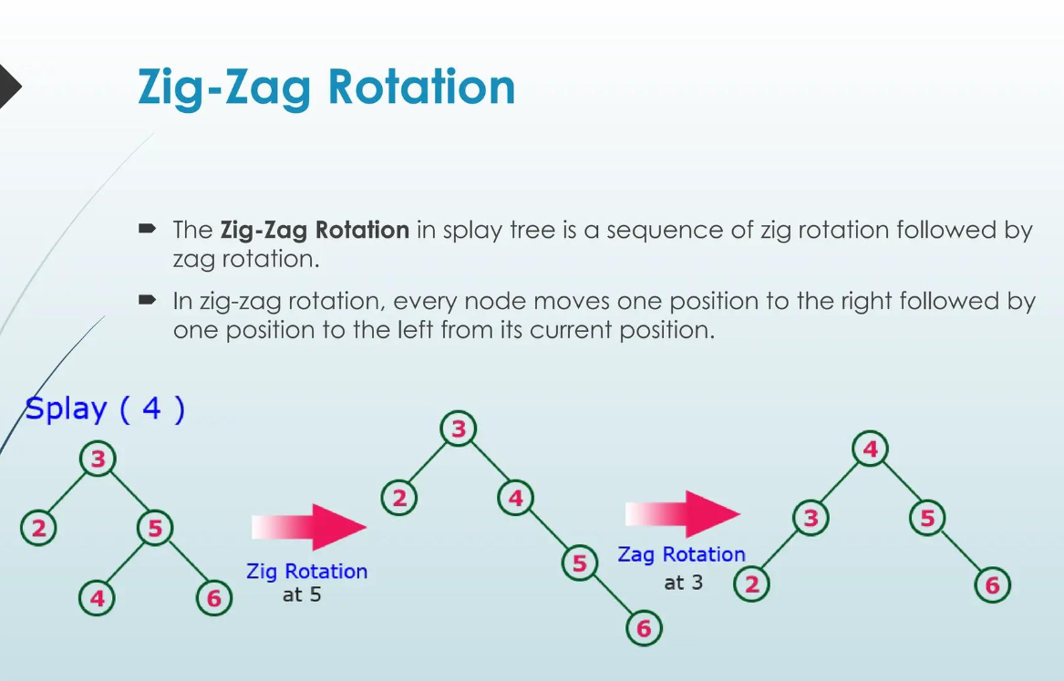
3. Operations
- Insertion: Insert the node using BST rules and splay it to the root.
- Searching: Search for the element and move the accessed node to the root.
- Deletion: Remove the required node and join the remaining subtrees.
4. Amortised Analysis
The amortised time complexity of common Splay Tree operations is:
O(log n)
However, a single operation can take:
O(n)
This means the average performance over a sequence of operations is efficient, even though individual operations may sometimes be slow.
5. Access Experiment
The rubric requires a workload of 10,000 accesses.
Record:
- Accessed key.
- Root after each access.
- Number of rotations.
- Average access time.
- Worst access time.
Use the same access sequence to compare a Splay Tree with another suitable data structure.
Actual measurements must be obtained from program execution.
6. Splay Tree and LRU Comparison
Splay Tree | LRU
Self-adjusting search tree | Cache replacement policy
Moves accessed nodes to root | Maintains recently used items
Supports searching and insertion | Manages cache entries
Uses rotations | Uses recency information

Conclusion: Splay Trees are suitable when certain elements are accessed more frequently than others. They improve repeated access performance by moving recently accessed nodes to the root.

Implementation:
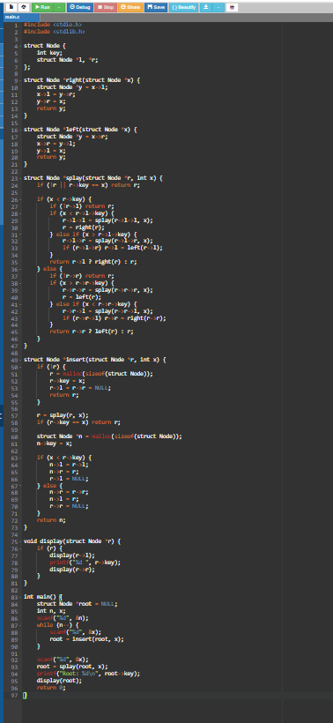
Input:
5
10 20 30 40 50
20
Output:
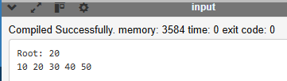

Q6. Tries
1. Introduction
A Trie is a tree-based data structure used to store and retrieve strings. Each node represents a character, and a path from the root represents a word or prefix.
Tries are commonly used in autocomplete, dictionaries and search suggestions.
2. Trie Structure
Consider the words:
- CAT
- CAR
- CAN
- DOG
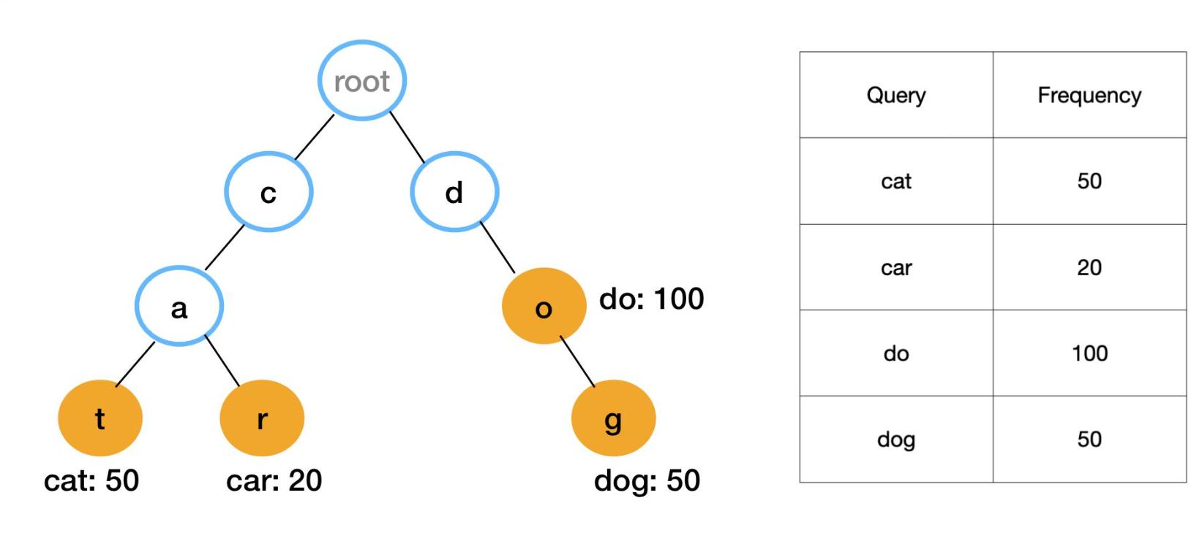
Words with common prefixes share the same initial nodes.
For example, CAT, CAR and CAN share the prefix CA.
3. Basic Trie Operations
Insertion: Start from the root and insert one character at a time. Create a new node if the character does not exist.
Searching: Follow the character path. If all characters exist and the final node represents the end of a word, the word is found.
Prefix Search: Check whether the given prefix exists in the Trie.
Deletion: Remove the word's end marker. Delete unnecessary nodes only when they are not shared by other words.
Autocomplete: Find the prefix node and display all words that continue from that node.
4. Time Complexity
Let L be the length of the word.
Operation | Time Complexity
Insertion | O(L)
Searching | O(L)
Prefix Search | O(L)
Deletion | O(L)
Autocomplete | Depends on the number of matching words

5. Node and Memory Calculation
If each Trie node contains an array of 26 child pointers and one end-of-word flag, its approximate memory requirement is:
Memory = 26P + 1
where P is the size of a pointer in bytes. This is a simplified calculation and excludes structure padding and allocator overhead.
For example, on a system with 8-byte pointers:
Memory = (26 times 8)+1=209text{ bytes}
The actual allocated memory may be larger because of alignment and other overhead.
6. Autocomplete Example
Suppose the Trie contains:
- apple
- application
- apply
- banana
- ball

For the prefix app, the autocomplete output is:
apple
application
apply

7. Testing
The following tests should be performed:
Test | Expected Result
Insert a new word | Word inserted
Search existing word | Word found
Search missing word | Word not found
Search existing prefix | Prefix found
Search absent prefix | Prefix not found
Delete a word | Word removed
Autocomplete | Matching words displayed

The assignment also requires completing the supplied TODO code, testing with AddressSanitizer (ASan), and verifying the stated step counts and growth table. Those exact step counts and input sizes are not fully defined in the information provided, so they must be checked against the original code or question sheet.
Conclusion: Tries provide efficient string searching and prefix matching. They are especially useful for autocomplete and dictionary applications.

Implementation:
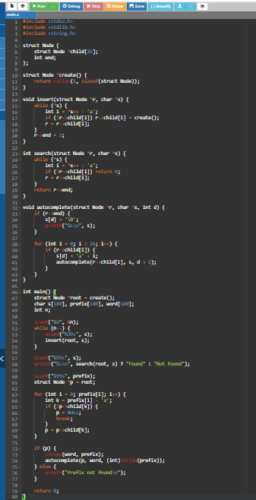
Input:
5
apple
application
apply
banana
ball
apple
app
Output:
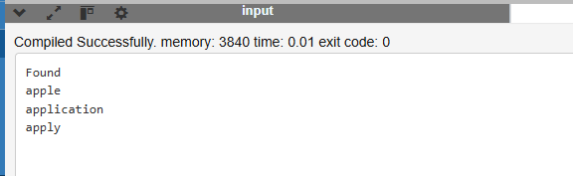
Q7. Tree Structure Design from First Principles
1. Introduction
Choosing an appropriate tree structure is important for developing efficient data storage and retrieval systems.
Different tree structures provide different advantages depending on the application, number of elements, searching requirements and memory limitations.
2. Requirements Analysis
The following requirements should be considered when selecting a data structure:
- Fast searching.
- Efficient insertion and deletion.
- Proper memory utilisation.
- Ability to handle increasing amounts of data.
- Predictable performance.
- Easy implementation and maintenance.
3. Comparison of Candidate Data Structures
Data Structure | Searching | Insertion | Main Advantage
BST | Average O(log n), worst O(n) | Average O(log n) | Simple implementation
AVL Tree | O(log n) | O(log n) | Strict balancing
Red-Black Tree | O(log n) | O(log n) | Efficient updates
B-Tree | O(log n) | O(log n) | Suitable for databases
Splay Tree | Amortised O(log n) | Amortised O(log n) | Frequently accessed keys move to root
Trie | O(L) | O(L) | Efficient prefix searching
4. Selected Data Structure
For a database application that stores a large number of records, a B-Tree is a suitable choice.
Reasons:
- Stores multiple keys in each node.
- Reduces the overall height of the tree.
- Minimises disk accesses.
- Supports efficient insertion and searching.
- Maintains balanced tree structure.
5. Implementation and Verification
The selected structure should be implemented and tested using different input sizes.
The following tests should be performed:
- Empty data structure.
- Small input.
- Large input.
- Duplicate values.
- Missing keys.
- Smallest and largest keys.
- Repeated insertion and searching.
The results should be compared with the expected output.
6. Complexity Analysis
For a B-Tree, searching and insertion generally require logarithmic time with respect to the number of stored keys.
Operation | Complexity
Searching | O(log n)
Insertion | O(log n)
Traversal | O(n)
Space | O(n)

7. Performance Evaluation
Performance should be evaluated using:
- Execution time.
- Number of comparisons.
- Number of disk accesses.
- Memory consumption.
- Tree height.
The actual measured values should be recorded in a table after executing the implementation.
8. Scale-Up Plan
When the number of records increases:
- Increase the number of stored records.
- Measure the execution time.
- Check the height of the tree.
- Measure the number of node accesses.
- Evaluate memory utilisation.
- Compare the results for different input sizes.
9. Limitations
Although B-Trees are suitable for large database systems, they require more complex implementation than ordinary BSTs. Node splitting and key management also increase implementation complexity.
Conclusion: Selecting a suitable tree structure depends on the application requirements. B-Trees are a good choice for large database storage because they reduce disk accesses and support efficient searching and insertion.

Implementation:
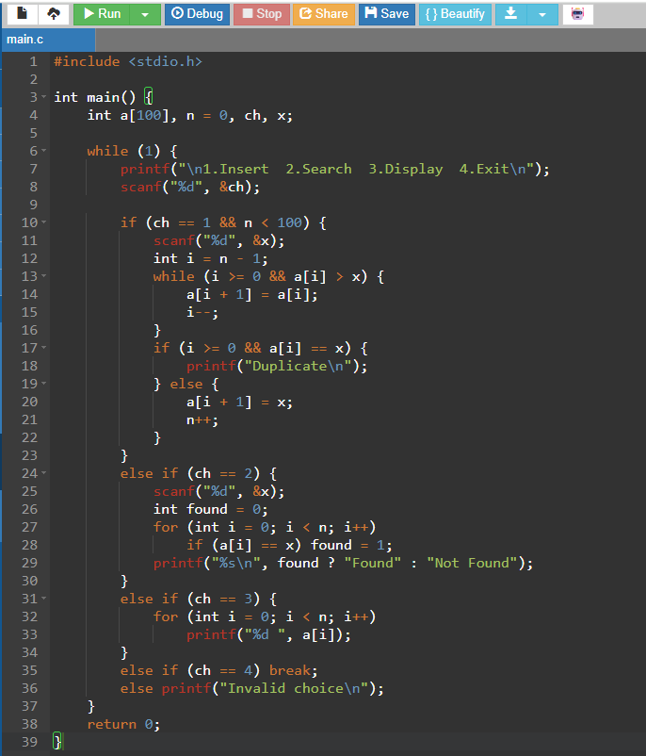
Input:
1
105
1
102
1
110
3
2
105
4
Output:


